# Accessing Kerry Student Timetabling Applications

## To access the Kerry Campus web class and exam timetables, you will need to follow these steps:

1. In the Microsoft EDGE browser enter the following URL

**https://myapplications.microsoft.com/**

NOTE: If you are not logged into MyBan already in the same browser, you will be

prompted to login so you will need to use the same credentials as your ‘MyBan’ (Student Self Service Portal) i.e. login : [studentID@mymtu.ie](mailto:studentID@mymtu.ie) and pw: your ‘MyBan’ password

1. Enter your your ‘MyBan’ login (e.g. [studentID@mymtu.ie](mailto:studentID@mymtu.ie)) and click ‘Next’ button

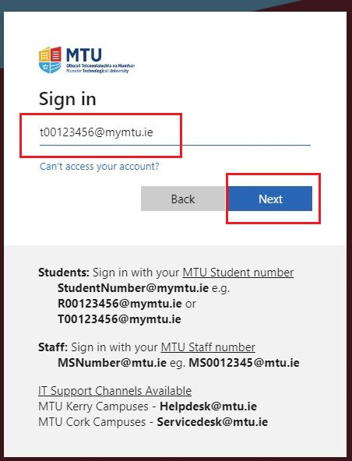

1. Enter your ‘MyBan’ password and click the “Sign in” button

Note: you will then have to MFA when prompted

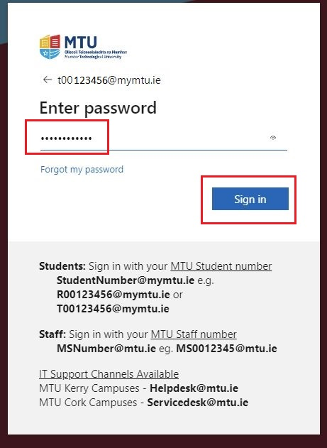

1. To MFA, you can click on the ‘Text’ option to get a verification code sent from Microsoft to your mobile number.

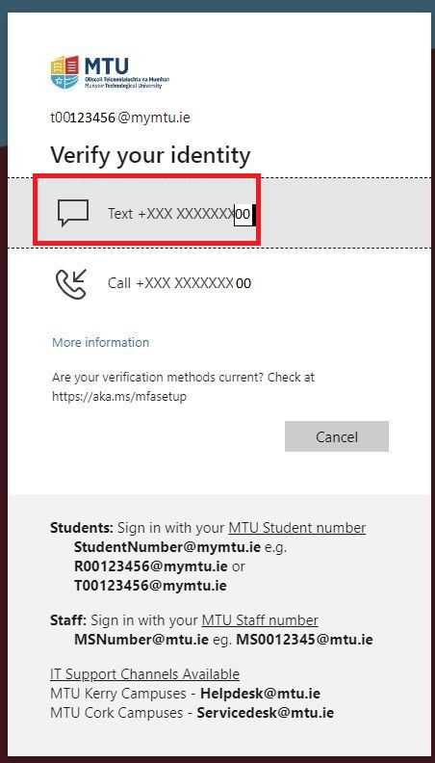

1. Enter the verification code (sent in a text message to your mobile phone) and click on the “Verify” button

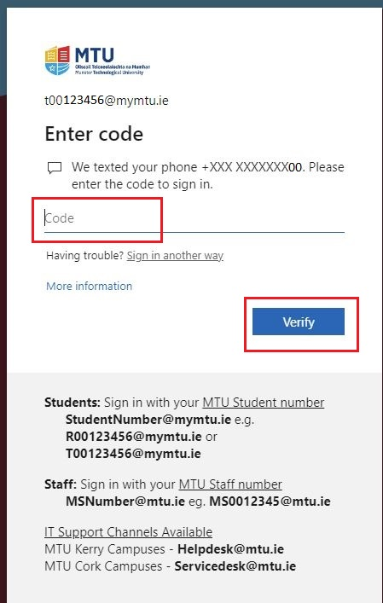

1. Once logged in, click the “Student Apps” tab to filter the Kerry Apps you have access to:

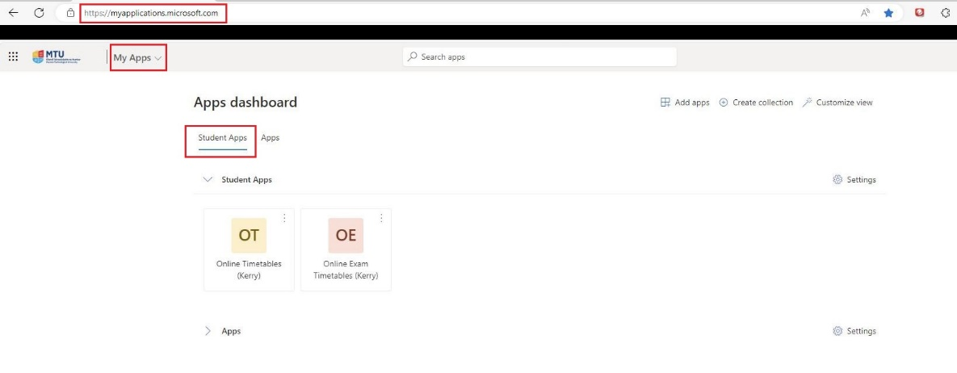

1. You will then see a listing of all the student applications you have access to:

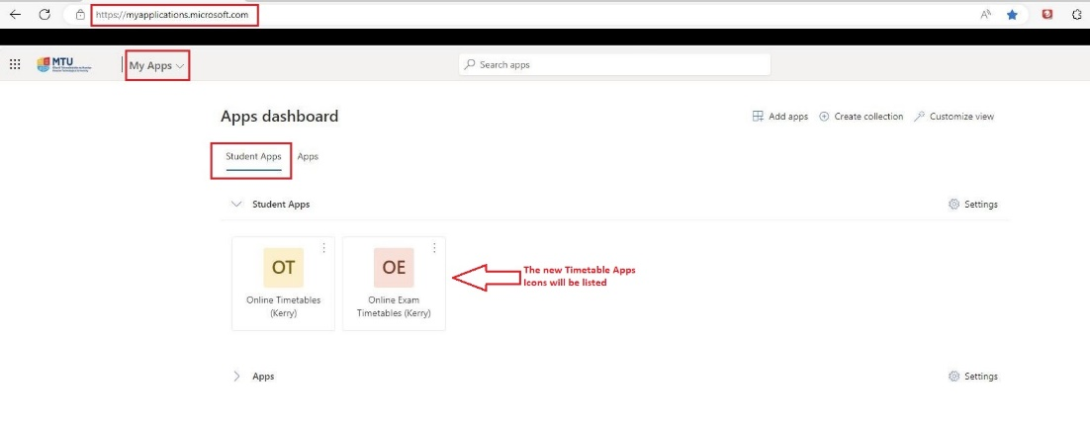

## Online Timetables (Kerry)

### To view your class timetables, on the MyApps “Student Apps” tab, select 'Online Timetables (Kerry)’

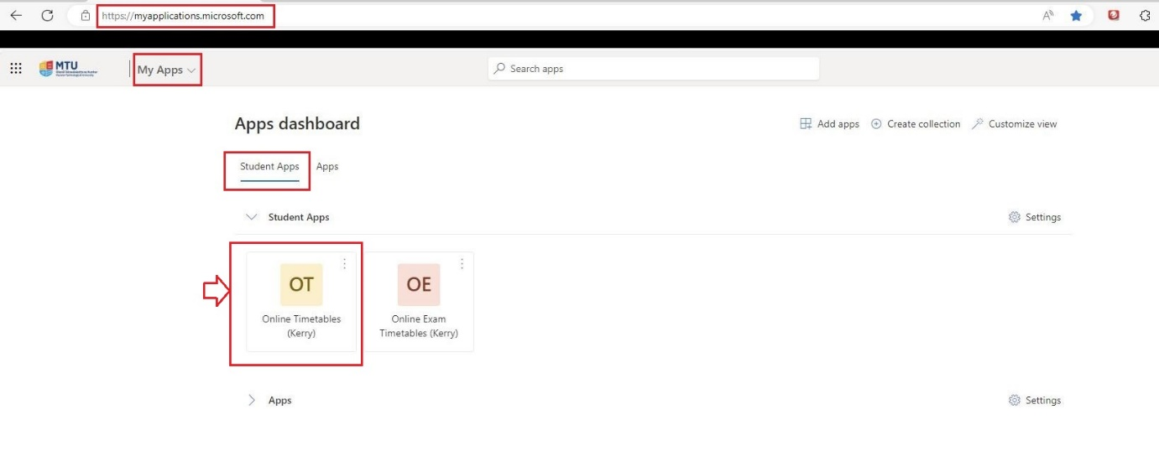

1. The Online Timetable (Kerry) SWS page will appear.

PLEASE NOTE: The title of the page will indicate the Academic Year (AY) the timetables apply to. The new AY timetables are usually released in early September. As soon as they are released, the title of this page will change to reflect the new AY.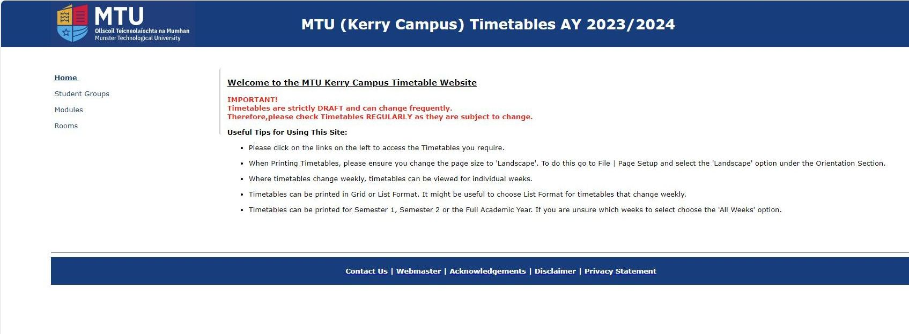

### Online Exam Timetables (Kerry) Web Page

1. To view your Exam timetables, on the MyApps “Student Apps” tab, select ‘Online Exam Timetables (Kerry)’

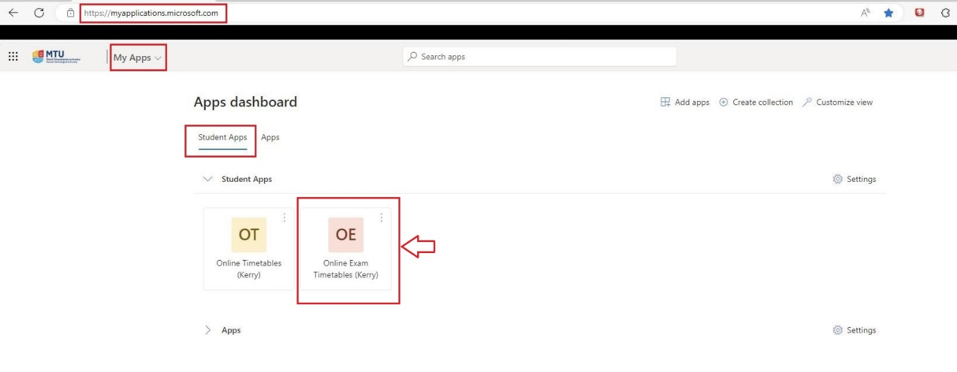

1. The Kerry Exam Timetable web page will appear.

